HEAVEN
Bitchen Wolf

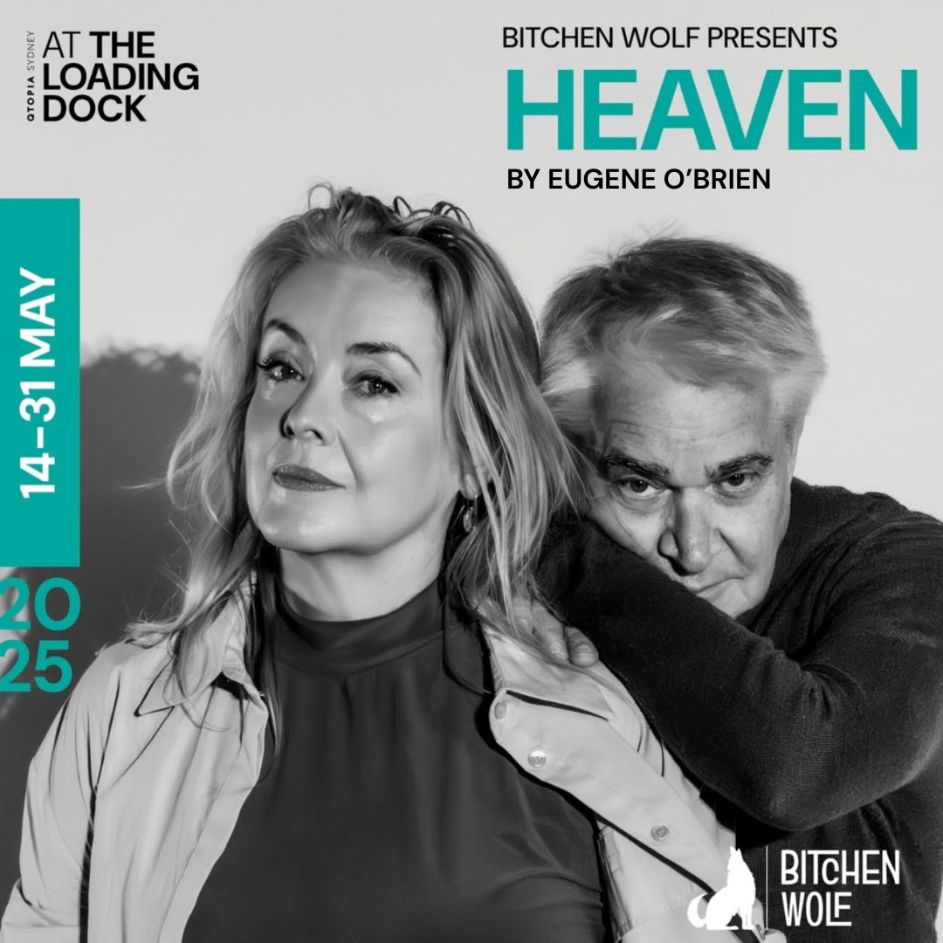

Kate Gaul (Director)
Kate.jane.gaul@gmail.com

⭐⭐⭐⭐ “ the strength of “Heaven” rests heavily upon the performance of its two leads and Kate Gaul’s compassion-driven direction. Having proven their chops many times over, it’s no surprise the actors carry their roles beautifully, with only a few patches of rushed pacing to find fault with … Miller…is a divine stage presence. Vivacious, unabashed and arch, she eats the cream of her lines and licks her fingers afterwards.” SMH - http://smh.com.au/culture/live-reviews/secrets-and-lies-laid-bare-in-this-tender-two-hander-20250517-p5m01a.html

⭐⭐⭐⭐ “Eugene O’Brien’s 2022 play won the Irish Times Award for Best New Play before picking up The Scotsman’s “Fringe First Award”, and rave notices in New York, Dublin and Edinburgh. It’s easy to see why in Kate Gaul’s beautifully balanced production at Qtopia. The script is illuminating, elliptical, and through two mesmerising performances from Noel Hodda (Mal) and Lucy Miller (Mairead), it casts light, welcome and otherwise, on the dark recesses of a long marriage.
It’s funny when it’s not disturbing and scarily enlightening if you can bear to look yourself in the eye. Short season of a truly rewarding play and production.” STAGE NOISE - https://www.stagenoise.com/review/2025/heaven

“This is a beautiful play, beautifully presented … Miller’s Mairead is gloriously tough….. a magnificently rounded portrait, strength sparring with uncertainty, delivered with captivating power…. Kate Gaul’s direction is wonderfully simple, unaffected in a way that allows the brilliance of the writing and performance to shine.

Lucy Miller and Noel Hodda are absolutely superb…. Hodda…marvellously portrays the internal battle between desire and doubt…. this production – an exploration of the tension between our inner and outer worlds, epitomised in its presentation of a marriage under threat – achieves the perfect marriage between artistry and Art.” THEATRE REDS - https://theatrereds.com/2025/05/19/heaven/

⭐⭐⭐⭐ “The performances by Hodda and Miller are captivating.” BACCUS AT THE THEATRE - https://bacchusatthetheatre.com/2025/05/18/heaven-qtopia-review/

⭐⭐⭐⭐ “the production’s closeness intensifies its impact. Every line lands clearly, every expression matters. With only subtle musical cues, the emotional texture is carried entirely by the strength of the performances – and both Miller and Hodda deliver.” WHAT’S THE SHOW - https://whatstheshow.com.au/heaven-the-longing-beneath-the-surface/?fbclid=PAQ0xDSwKWKSdleHRuA2FlbQIxMQABp1RvGJBTSOzFn9Ocme6CwQl9bd1h9PaSSVxR4h3gj6xQbE-aWG-v07dHoAwl_aem_dZQf3Y2oMf7a5MjJoQjNTw

⭐⭐⭐⭐ “Lucy Miller and Noel Hodda bring life, charm and warmth to Mairead and Mal but it is director Kate Gaul’s careful styling of pace and tone of this challenging script which pulls it together.” THEATRE NOW - https://theatrenow.com.au/theatre-now-review-heaven/

“Lucy Miller and Noel Hodda are stellar in “Heaven” … In this superb play at Qtopia, we’re encouraged to find meaning in what has been and, if we like, change what is to come.”
CITY HUB - https://cityhub.com.au/heaven-a-gorgeous-rumination-on-past-and-present-desire/

“This is an absolute gem of a play … the set is simple: a bench, and a backdrop that, thanks to lighting designer Topaz Marlay-Cole, could be heavenly stars or the glitzy lights of a wedding venue. Kate Gaul’s direction is tight, and the 100 minutes go by almost in a flash as we, like Mairead and Mal, wonder at playwright Eugene O’Brien’s underlying question: what should we do to truly live.
“Heaven” is a fierce, very funny, and heart-wrenching exploration of identity, regret, and the lives we secretly long for.” MEGAPHONE OZ - https://megaphoneoz.com/review-heaven-at-the-loading-dock-darlinghurst/

“Heaven” is a tender, haunting look at love, regret, and the versions of ourselves we never got to be. If you’ve ever felt stuck or wondered “what if?”, this play will hit home.” THEATRE TRAVELS - https://www.theatretravels.org/post/review-heaven-at-the-loading-dock-qtopia-sydney

“Directed with elegant restraint by Kate Gaul, “Heaven” is driven by two intertwined monologues that lay bare the complex inner life of Mairead and Mal … unveiling a tapestry of missed chances intertwined with deep, enduring affection that has quietly shaped their years together.

Hodda and Miller bring humour and sharpness to O’Brien’s lyrical world, revelling in the emotional turbulence of middle-age… It is a quiet, yet unforgettable reminder of the beauty found in life’s most fragile moments.” FAITH IN THEATRES - https://www.faithintheatres.com.au/heaven/

“Kate Gaul’s production keeps things simple and focused. This play is all about the charisma of the two performers, with nothing to distract you, and is the better for it. Miller is dynamic as the rough and fiery Mairead … balancing her is Hodda’s charming, bumbling Mal, who goes on a wilder adventure.” CULTURAL BINGE - https://culturalbinge.com/2025/05/21/heaven-qtopia/

“Hodda is endearingly authentic … Miller is cutting and commanding … two fine actors voicing an exquisitely written play...” STAGE WHISPERS - https://www.stagewhispers.com.au/reviews/heaven-0

“Hodda was eminently present. It was the best I've seen him. Miller projects the intensity and regrets of years of frustration. Gotta love an actor who can cry on cue!” SYDNEY CHIC - https://www.sydneychic.com.au/post/theatre-review-heaven-by-eugene-o-brien

“rich and raw, raunchy and poignant” SOUTH SYDNEY HERALD - https://southsydneyherald.com.au/heaven/

“ the performances are outstanding…” SYDNEY THEATRE REVIEWS - https://sydneytheatrereviews.com/heaven-the-loading-dock-theatre-qtopia/

“... directed by Kate Gaul with elegant conciseness, “Heaven” speaks with simplicity, about notions of personal fulfilment ... convincing performances by the cast inspire meditations on the meanings of freedom and selfhood.” SUZY GO SEE - https://suzygoessee.com/2025/05/16/review-heaven-qtopia/

“With their talents and years of experience on stage and screen, they bring strong, convincing performances to the stage, generating a stirring mix of pathos and mirth; relatability and disdain.” ARTS HUB - https://www.artshub.com.au/news/reviews/theatre-review-heaven-loading-dock-theatre-qtopia-sydney-2797080/

