THE END OF WINTER
Siren Theatre Co (Australia)

The End of Winter is a rich imaginative story which asks: will climate change erase winter leaving it to exist only in fairy tales, paintings, and historical accounts?

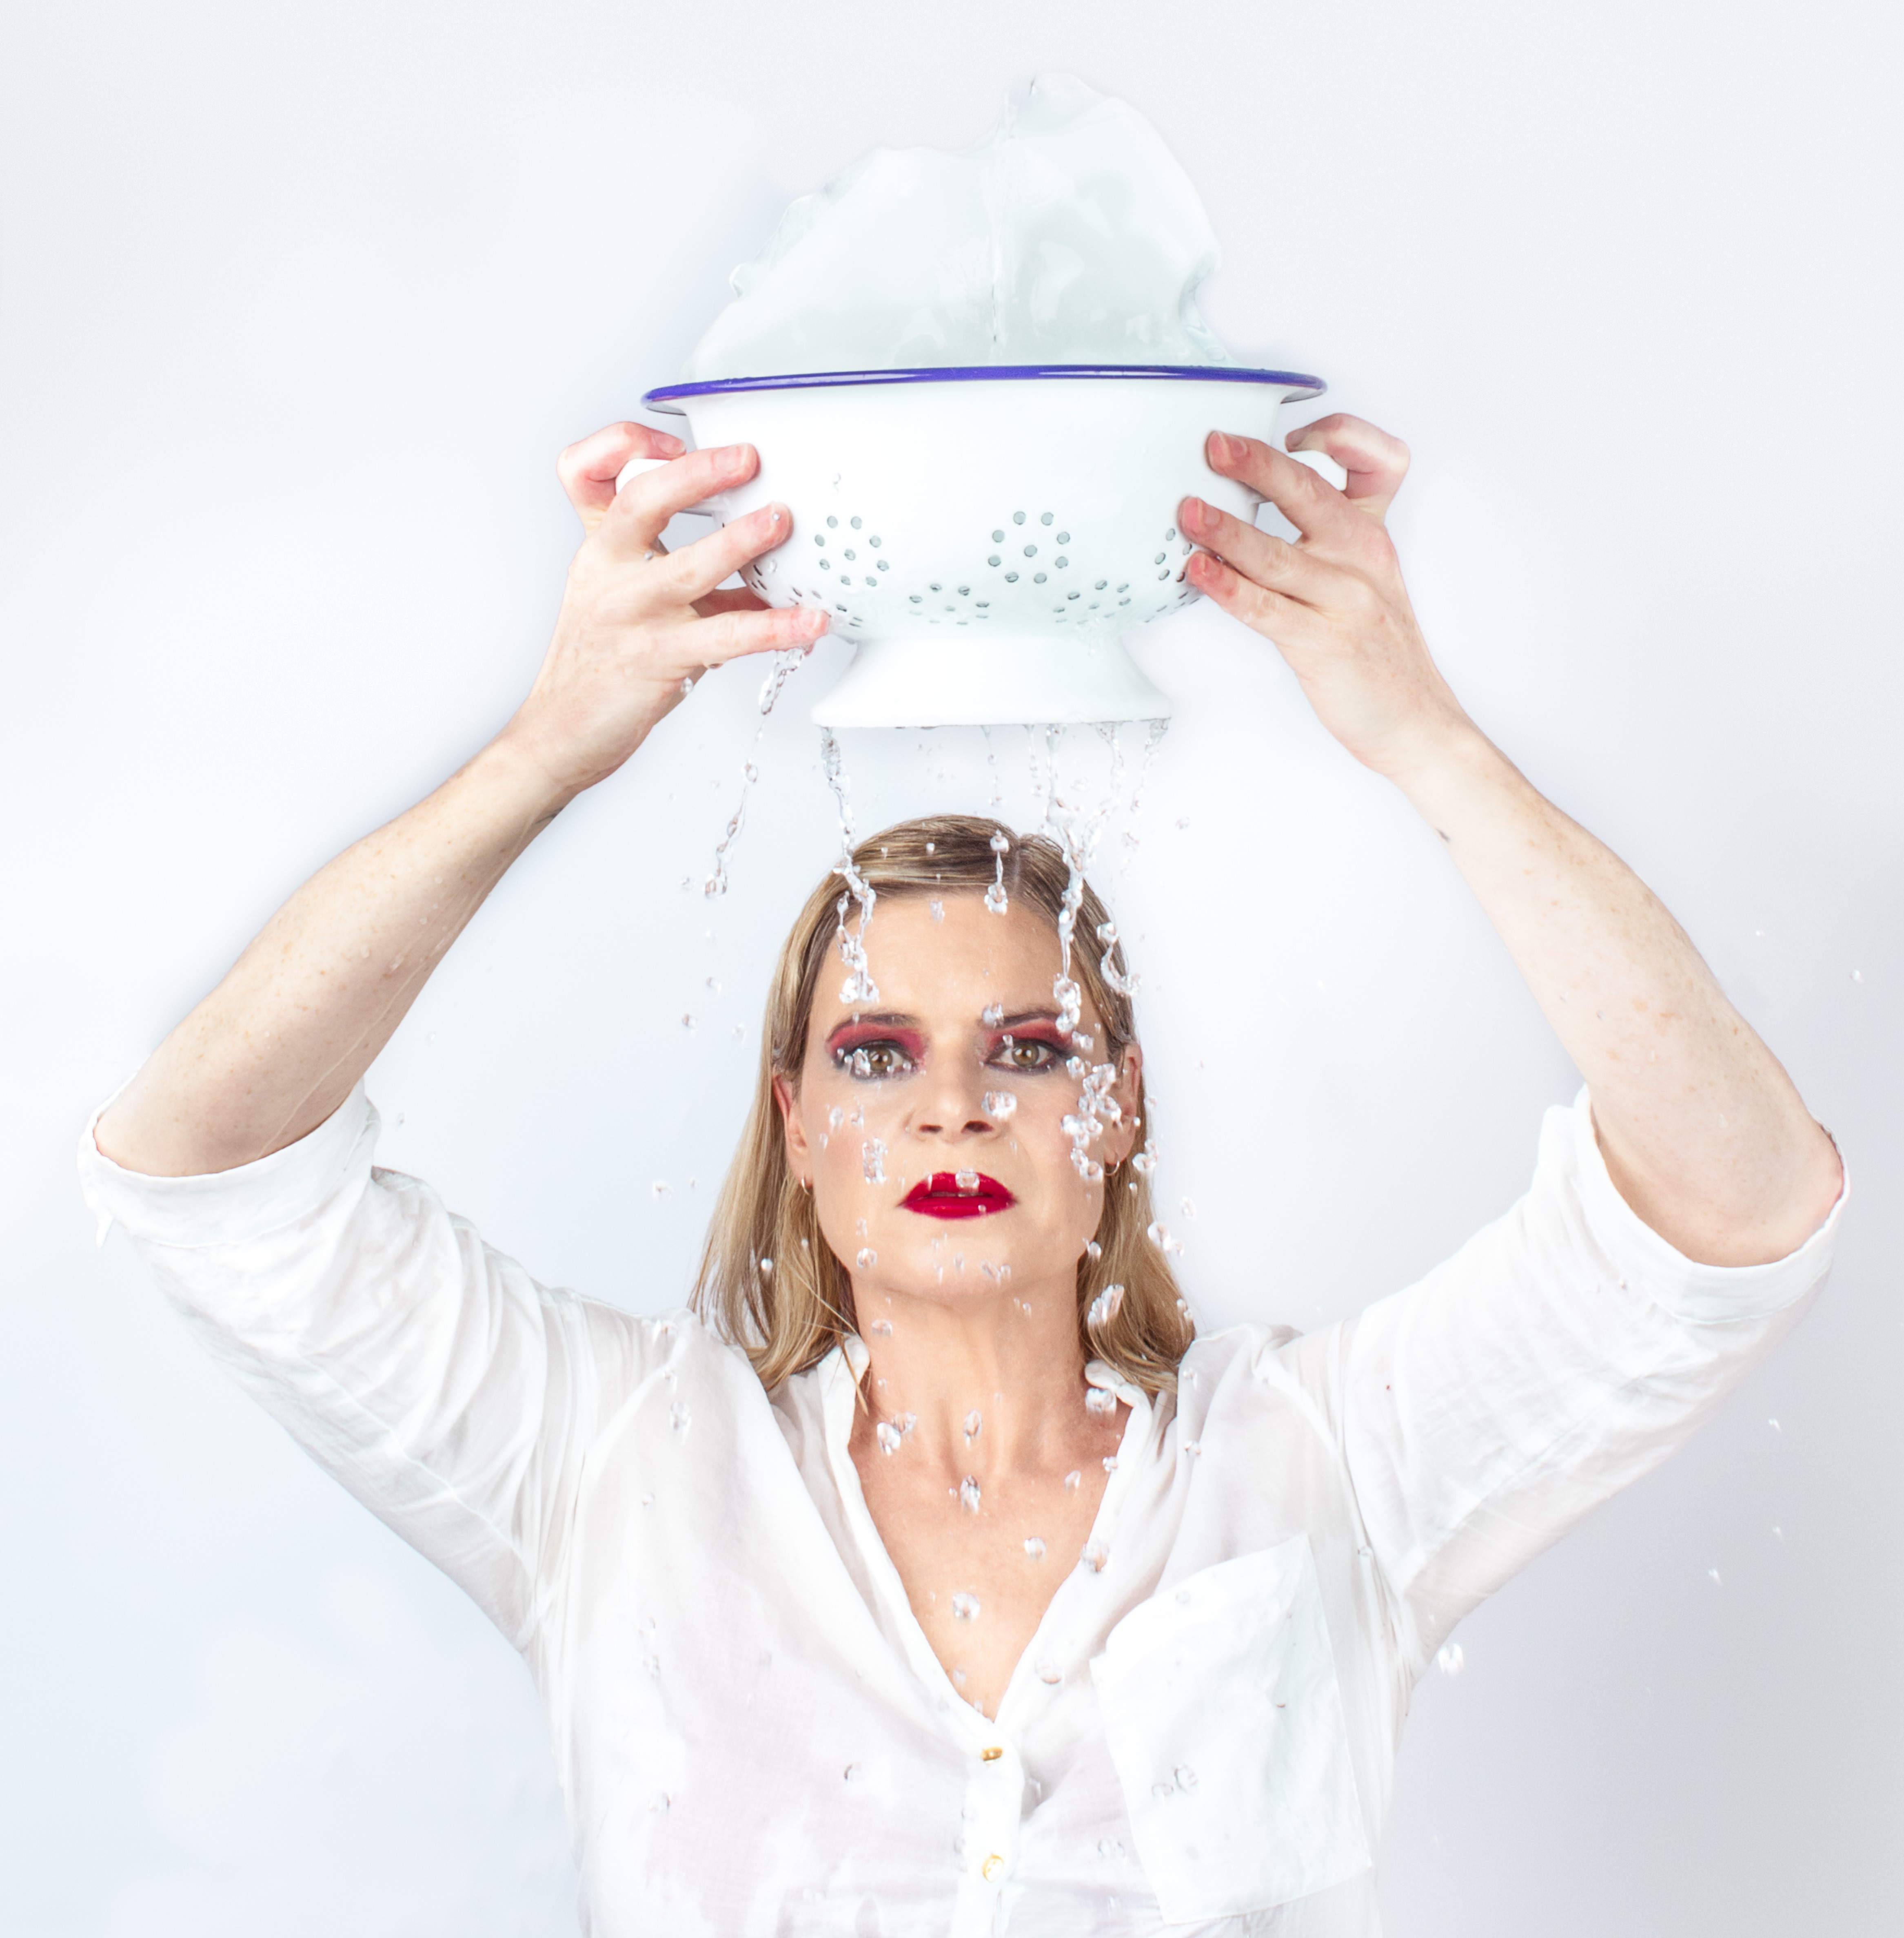

Contact
Kate Gaul
Siren Theatre Co
Kate.jane.gaul@gmail.com
0417 247 105

ABOUT THE SHOW
The End of Winter is a solo work written by Noëlle Janaszweska and performed by Jane Phegan.

CREATIVE TEAM
Writer Noëlle Janaszweska
Director Kate Gaul
Production Designer Soham Apte
Composer Nate Edmondson
Lighting Designer Becky Russell

Performer Jane Phegan

HISTORY
2022 Premiere Season SBW Stables Theatre, Sydney 2 -12 February, 2022
2023 Extensive Australian Tour

AWARDS
Winner: Best Actor in and Independent Production Sydney Theatre Critics Awards
Shortlisted: NSW Premier’s Prize for Playwrighting 2023

MARKETING INFORMATION

Billing | Siren Theatre Co in association with <Presenter Name>  presents  The End of Winter by Noëlle Janaczewska
Artist Credits | Writer Noëlle Janaszweska  Director Kate Gaul  Production Designer Soham Apte  Composer Nate Edmondson  Lighting Designer Becky Russell  Performer Jane Phegan
Copy - SHORT | Will climate change erase winter leaving it to exist only in fairy tales, paintings, and historical accounts? In hot, bushfire-prone Australia our winters are becoming warmer and shorter. The End of Winter is about loss and resilience. It’s about the places one can search for cold weather —places that can be reached via public transport and the imagination.
Copy - EXTENDED  For season  brochures/flyers, program guide listings | Siren Theatre Co and the award-winning team behind Good With Maps are collaborating again on Noëlle Janaszewska’s The End of Winter.  Will climate change erase winter leaving it to exist only in fairy tales, paintings, and historical accounts? In hot, bushfire-prone Australia our winters are becoming warmer and shorter. The End of Winter is about loss and resilience. It’s about the places one can search for cold weather —places that can be reached via public transport and the imagination.  This is a new work for the stage that speaks to our current climate crisis. Written in the wake of the devastation of the 2019 bush fires it asks: What’s happening to winter?  Noëlle Janaczewska is a multi-award-winning Australian writer whose plays, radio scripts, libretti, fiction, and essays have been performed, broadcast, and published throughout Australia and overseas.  From Kate Gaul: “Noëlle’s unfailing ability to ignite universal emotions and laughter in all of us while gloriously revealing her own exquisite uniqueness is one of this piece’s great joys. This is a feminist work, which explores shifting identites - writer, child, carer, lover, explorer.”  The themes and ideas contained within The End of Winter lean into the most significant issue of our time – the changing climate and the loss of seasons.  Telling and sharing stories, from the scientific to the personal, is one the most important tools we have to survive climate change. It’s easy to get into a typical conversation about the weather. It’s harder to talk about how changing weather patterns relate to climate change - especially when climate and weather can often get confused. In Australia, we’ve experienced it all: extreme heat, devastating droughts, raging bushfires, floods, and cyclones. But these extreme weather events are getting worse as the world heats up.
Logos | Siren Theatre Co  Create NSW  Logos Here -https://www.dropbox.com/sh/wy1exsvvtrcbj16/AACURTMnJcY505u45Z8aXnlHa?dl=0  (Logo must be included on all advertising and promotional material associated with the tour and performances of The End of Winter unless explicitly agreed otherwise, including, but not limited to, season brochures, flyers, posters, advertisements, media releases, promotional videos, web pages and programs.)
Acknowledgements | The End of Winter was first produced by Siren Theatre Co and opened in Sydney on 3 February 2022 at SBW Stables Theatre.  The End of Winter is supported by the NSW Government through Create NSW, it’s arts funding and advisory body.  (Acknowledgements must be included in addition to logos where space allows, including, but not limited to, season brochures, flyers, web pages and programs. These should also be acknowledged in speeches and announcements where appropriate.)
Duration | 55 minutes (no Interval)
Warnings | No warnings
Age Suitability | Adult (but suitable for ages 13+)
Target Audiences | Primary: Women, Subscriber, Climate Change groups  Secondary: Older people with declining parents  Themes: Climate Change, Travel, Adventure Stories, Colonisation, Feminism, Identity, Belonging
Hero Image  Graphic Design | https://www.dropbox.com/sh/krb3tethcqrp0s9/AACvs-MjPrSga-U0FCmcbBFMa?dl=0  https://www.dropbox.com/sh/2pz8ak4sdq3f50o/AADIyW61WyH3DRHO5HSVLLtla?dl=0
Images | https://www.dropbox.com/sh/v5dgj5vae9xzh15/AACLmriZZ3uDtd2VPdKMtBGYa?dl=0
Video links | Full Length (SBW Stables Theatre) - https://youtu.be/sQic_Rmt4xg  Full Length (Earl Arts Centre) - https://vimeo.com/862253008/3e70e91ccc  Trailer - https://youtu.be/AIekrF_ZQqs
Creative Notes | Can be supplied
Reviews | https://www.dropbox.com/sh/9z6k5ww9l6jzxcj/AABsxnGaFPX2Njq2S3-6nRjHa?dl=0
Artist Biographies: for use online, in printed programs, etc | https://www.dropbox.com/sh/p2ni2bj75lm0hax/AADstJfOEcyp3m4NHsAv9ToPa?dl=0
Websites | Siren Theatre Co: https://www.sirentheatreco.com/the-end-of-winter

